1. Get inside manager container
2. Check if python is installed. Pyspark requires at least python 3.7 or above.

$ python –version

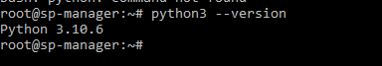

1. As we have python 3.10 , we are good to go with pyspark
2. Add spark home path in ~/.bashrc

$ nano ~/.bashrc

Add below path in the file and save.

export SPARK_HOME=/usr/local/spark  
export PATH=$SPARK_HOME/bin:$PATH

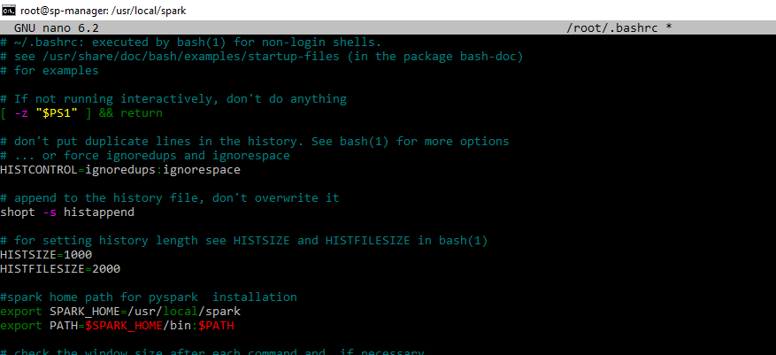

1. Restart the terminal
2. Verify pyspark

